Report on
Voting Machine Using Boolean Simplification
Submitted By:-
Gitanjali Jain(B243)
Koushani Bag(B270)
Naina Mittal (B282)
Date:-28/10/25
Submitted to:-
Dr. Naziya Hussain

Mukesh Patel School of Technology & Management Engineering
Department of Computer Science Engineering Vile Parle (w), Mumbai- 400056

TABLE OF CONTENTS
Section | Topic | Pg No.
1. | Introduction | 3
2. | Methodology | 4
3. | Findings/Results | 5
4. | Discussion | 7
5. | Conclusion | 8
6. | Recommendations | 9
7. | References | 10
8. | Appendix | 11

1. Introduction
A Voting Machine is a digital system designed to record and evaluate votes electronically. In this project, a combinational logic circuit is developed to determine the majority output among three voters. Each input represents a voter’s choice in binary form: 1 indicates the voter supports the candidate, and 0 indicates no support.
The system’s output will be 1 (Win) if the candidate receives two or more votes, representing a majority. Using Boolean algebra and K-map simplification, we reduce the circuit to use the minimum number of logic gates for efficient implementation.
Such digital systems form the foundation of modern electronic voting and decision-making systems in real-world applications.

2. Methodology
This project follows a systematic digital logic design approach using combinational circuit theory. The design is based on Boolean simplification and implemented with basic logic gates.
Steps Involved:
1. Define problem statement: determine majority among three inputs.
2. Create truth table.
3. Derive Boolean expression from truth table.
4. Simplify expression using Boolean algebra or K-map.
5. Implement simplified circuit using AND and OR gates.
6. Verify functionality using simulation and hardware model.
Software tools such as Logisim or Tinkercad were optionally used to validate logic before hardware implementation.

3. Findings/Results
The project successfully implements a majority voting machine using Boolean simplification.
Truth Table:
Output F = 1 when at least two inputs (A, B, C) are 1.
Simplified Boolean Expression:
F = AB + BC + AC
Circuit Design:
- Three 2-input AND gates generate AB, BC, and AC.
- Their outputs are connected to a 3-input OR gate.
- LED indicates winning condition (F = 1).
Hardware Components:
IC 7408 (AND), IC 7432 (OR), 3 toggle switches, LED with resistor, breadboard, and 5V DC supply.
Software Simulation:
The logic was verified on Logisim, confirming correct output for all input combinations.

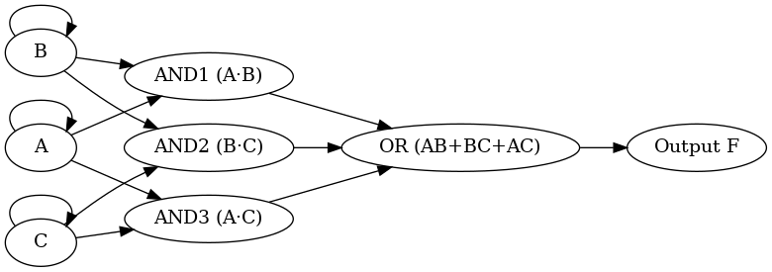
Circuit diagram
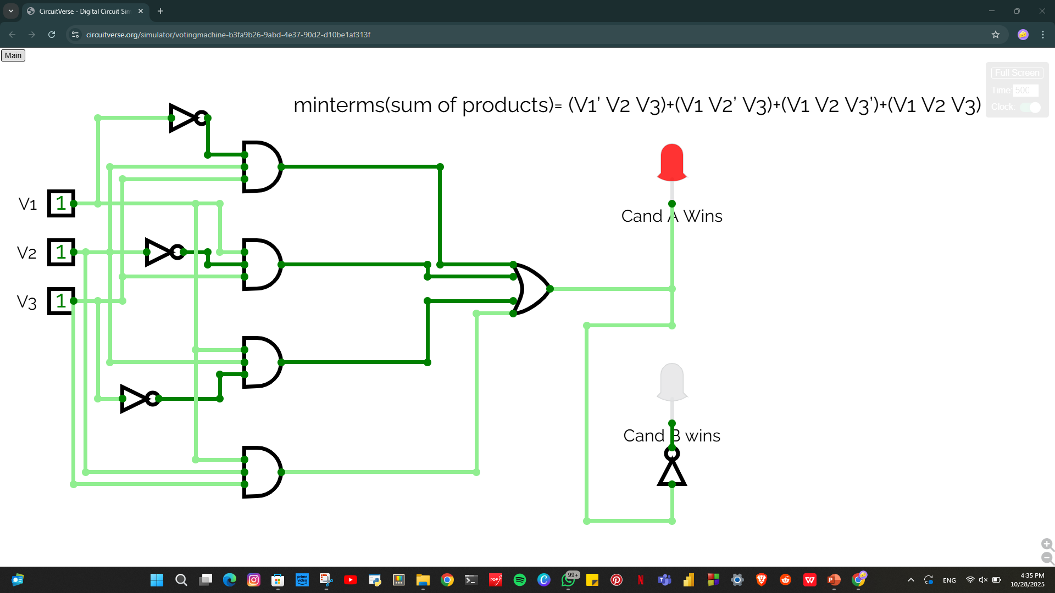
Working model

4. Discussion
The designed voting machine demonstrates the application of Boolean algebra in real-world decision-making systems.
The project simplifies complex voting conditions into minimal gate-level implementation, improving circuit efficiency and reducing hardware cost. The practical model verified theoretical results successfully.
This simple majority function can be extended to more voters, showcasing the scalability of combinational circuit design in larger systems such as microcontroller-based electronic voting or consensus algorithms.

5. Conclusion
The voting machine was successfully designed and implemented using Boolean simplification. The project achieves the majority function with minimal logic gates and demonstrates an efficient, reliable, and simple circuit design.
It validates the practical use of logic gate theory and Boolean simplification in decision-based circuits.

6. Recommendations
1. Extend the design to n-voter systems using programmable logic devices.
2. Implement microcontroller-based decision circuits for real-time applications.
3. Use simulation software (Proteus, Logisim) for enhanced analysis.
4. Develop digital display output instead of LED indicators for better visualization.
5. Explore FPGA or VHDL implementation for higher efficiency.

7. References
• M. Morris Mano, "Digital Logic Design"
• Logisim Simulation Software
• Tinkercad Circuits Online Simulator
• Nazia Hussain (Faculty Guide)

8. Appendix
The hardware model demonstrated that when two or more toggle switches (representing votes) were ON, the LED glowed—indicating a majority decision.
This confirms that the simplified Boolean equation F = AB + BC + AC accurately models majority logic.

